1. Hi Connection, from Few day’s , I am learning a AWS cloud and when I was learning a EC2 instance, I have experience the interesting thing at the Time of EC2 instance creation related to Key Pair login.

**Below steps are required to launch/create a new instance:**

1. Name and Tags: The name given to VM/EC2 instance.
2. Application and OS images (AMI):Contains the s/w configuration (OS, Server, Applications)
3. Instance type: Describe the computing, memory, networking, Storage requirement.
4. Key Pair Login: Using the key pair, we can securely connect to instance.
5. Networking Settings: VPC, subnet, auto assigned public ip, firewall(security group-manage the inbound and outbound services)
6. Configure Storage: Specify the storage option for the instance.
7. Advanced Details: Contains the Domain join directory, IAM instance profile, Hostname type,………..,etc and last user data( Commands or some script given by the user, to run once when instance launched).

**Key Pair: Unique key is generated for the instance**

1. We can create private key-pair for the EC2 instance/ or we can choose the previously created key for the new instance.

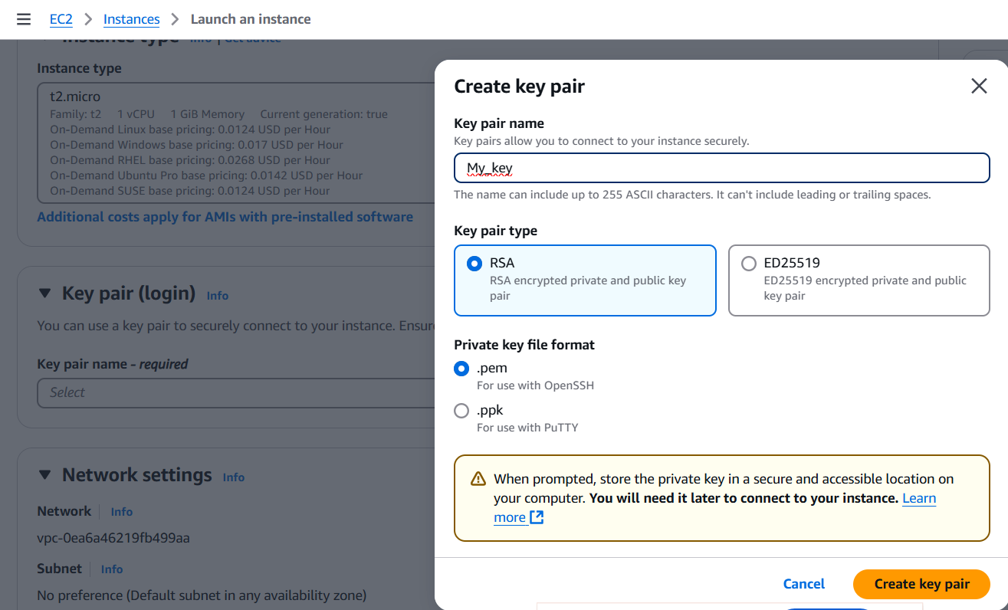

1. **How to connect to the instance**

To connect to created VM, the instate state must be in Running State.

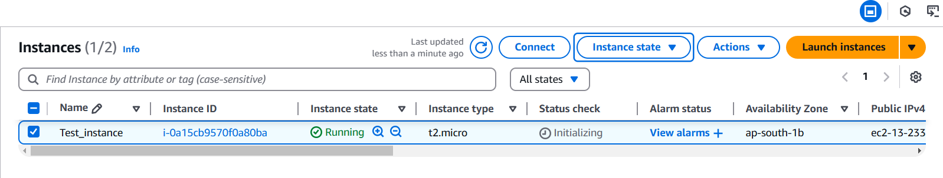

**There are 4 ways to make a connection with a VM:**

1)EC2 Instance Connect: We can connect without the Public IP to the resource.

2)Session Manager: Fully Managed AWS System Manager Capabilities, and manage the AWS EC2 instance.

3)SSH Client: Secure Shell provides a Command Line interface to connect to EC2 instance.

4)EC2 Serial Console: provides a access to EC2 instance serial ports, use for troubleshoot boot, network configuration, and other issues.

Networking capabilities not mandatory for the instance when, we use the serial console to connect.

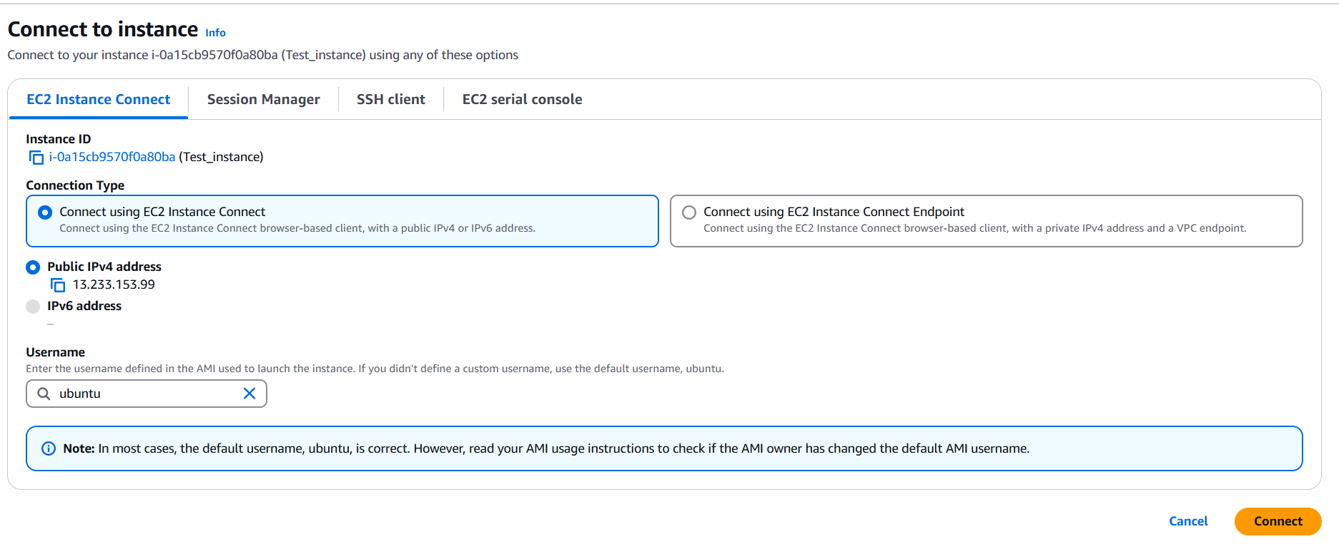

**How to connect using the SSH:**

**1)Using Putty**

If we have generated the Private key in .pem format then, we can’t add private key to the instance.

Putty Support: .ppk (putty private key format)

i)Format conversion using: putty key generator:

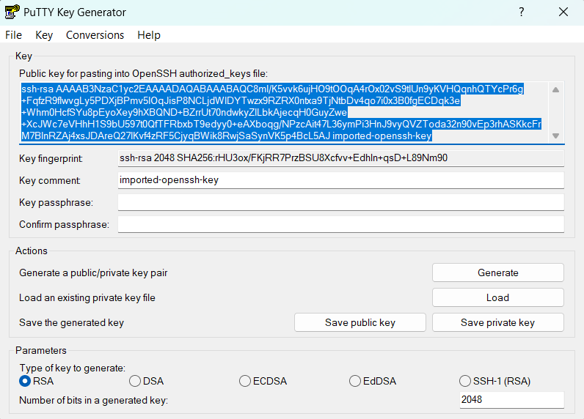

ii) Action: Search Putty gen ---> click on Load --->Select .pem file from your device (all files(*.*) )--->Save Private key with .ppk format.

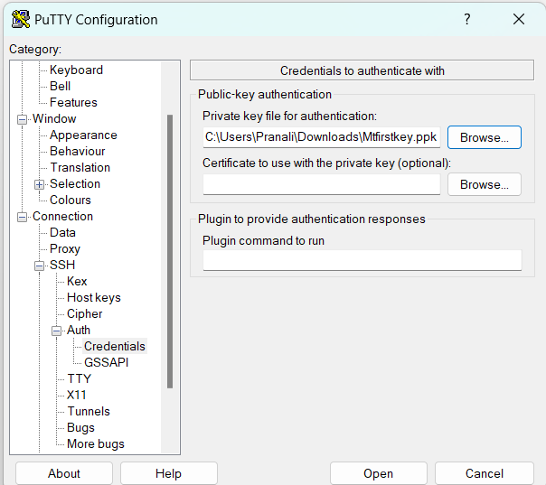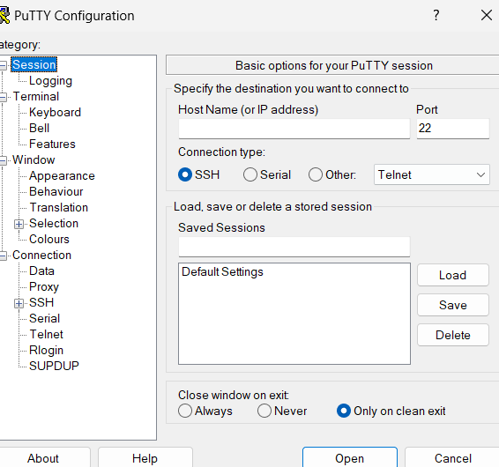

Open Putty to Connect:

1)Enter: Public IP of instance

2)Follow: connection/ssh/Auth/Credentials path

3)Add private key (.ppk)

4)click on open

5)Connection will establish.

6)Login as: username (Refer image.3)

ii)Output: Machine is ready to work

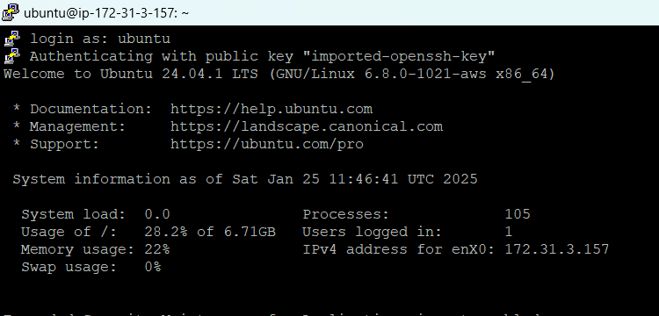

**2)Using Windows power shell:**

Commands: ssh -i path_of_private_key username@ip_address –VM will launched

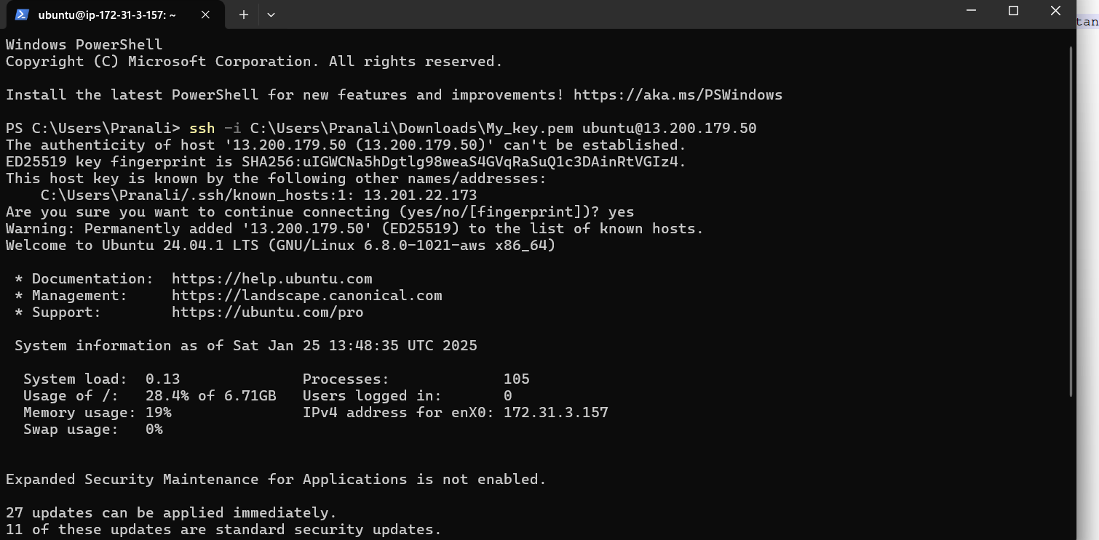

**What to do, when we lose/missed the downloaded private key of instance.**

1)Follow the below steps:

Connect to VM using: EC2 instance Connect Method

When instance launched: Then execute the below commands

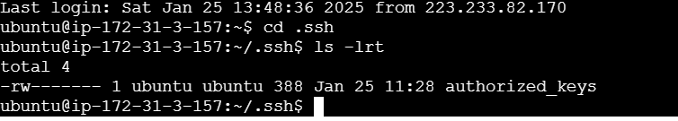

By using the vi/nano authorized_keys commands, editor will open and we can copy the old key or paste the new or one more key for the instance.

SQS: Simple Queue Service Practical:

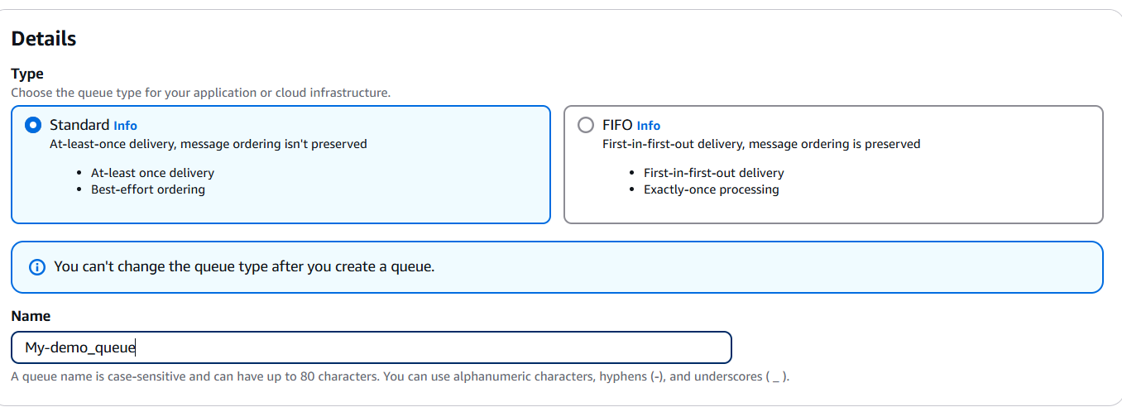

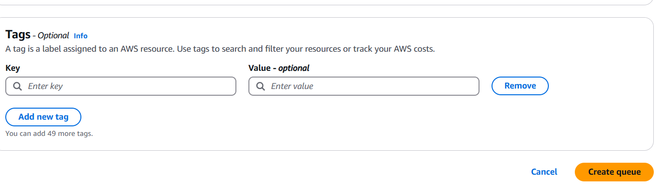

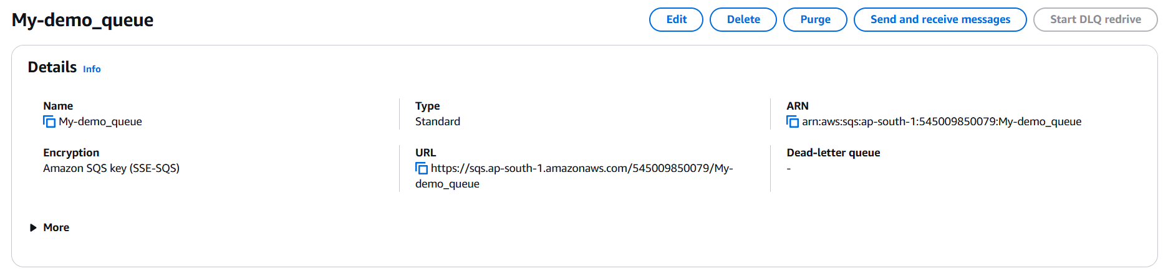

**Purging** a queue deletes **all messages** in the queue but **does not delete the queue itself**.

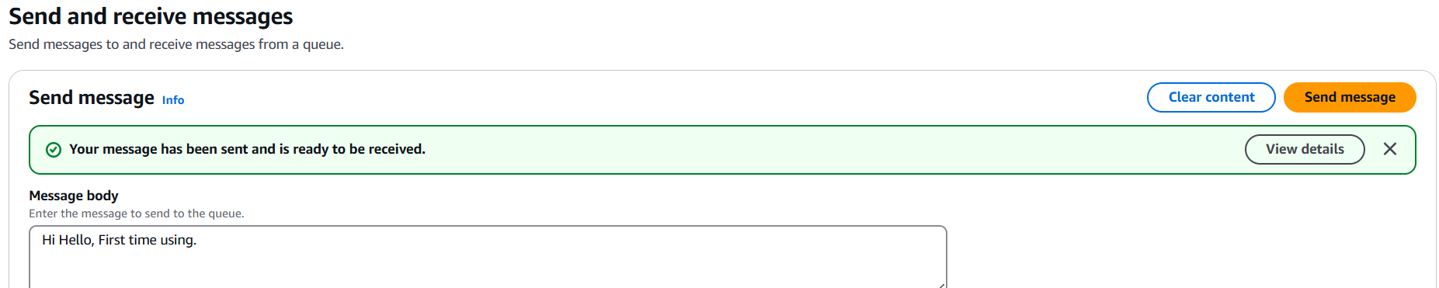

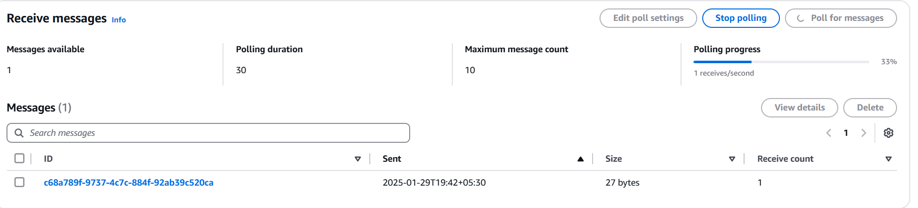

SNS : Simple Notification Service (one message to Many receivers) Publisher and Subscribe model

